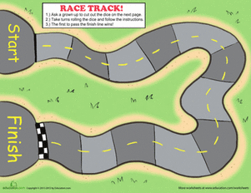

Colour scheme

Green for the grass around the track.

For the track, the colour scheme is grey with a yellow dotted line going through the middle. Also a black and white square is needed to show the difference between the start line and finish line.

A red outline is required around the rack.